**ASSIGNMENT -1**

* **Folder Structure**

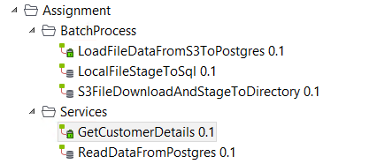

1. **Batch job:** This job can be scheduled on tac / linux crontab/windows task scheduler/Jenkins. Below is details of it.

* Get all connection, file metadata details from a xml file.
* Download File from s3 to local directory
* Load the data to the postgres db instance

postgres



csv

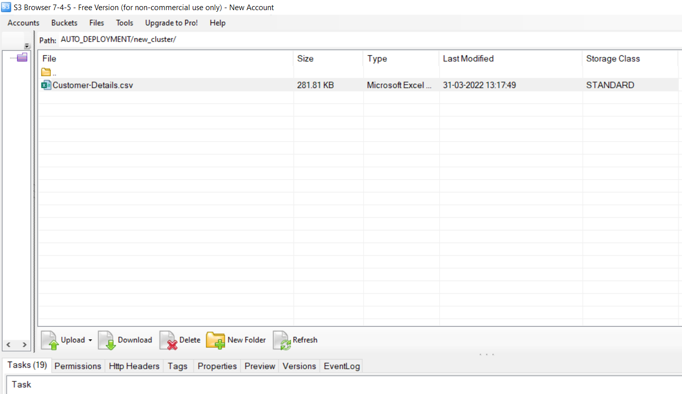 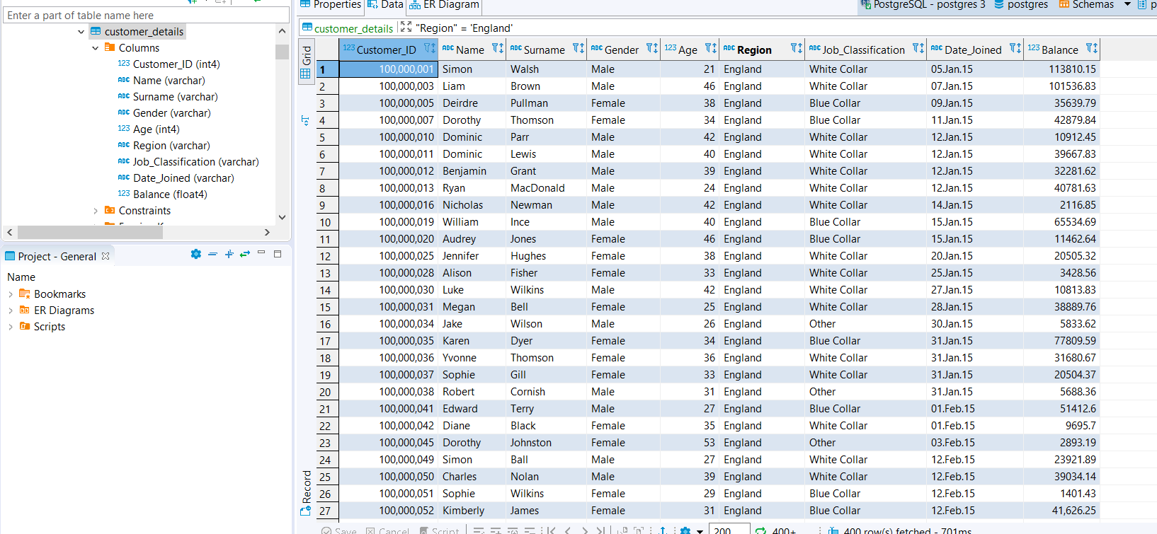

**Log File**



1. **Services:** This services can be build as osgi bundle and can be deployed to apache karaf.

Apache karaf (runtime)has a default feature to enable ssl on port 9001 which can enable client to do secure communication.

* Used TrestRequest with get protocol with two output flow one to get customer details based on region and other on Job Classification
* Response type can bet set on the trestResponse at runtime through header

Content-type=context.responseType where Response Type can be either Application/xml or Application/json for a customer

Screenshots:

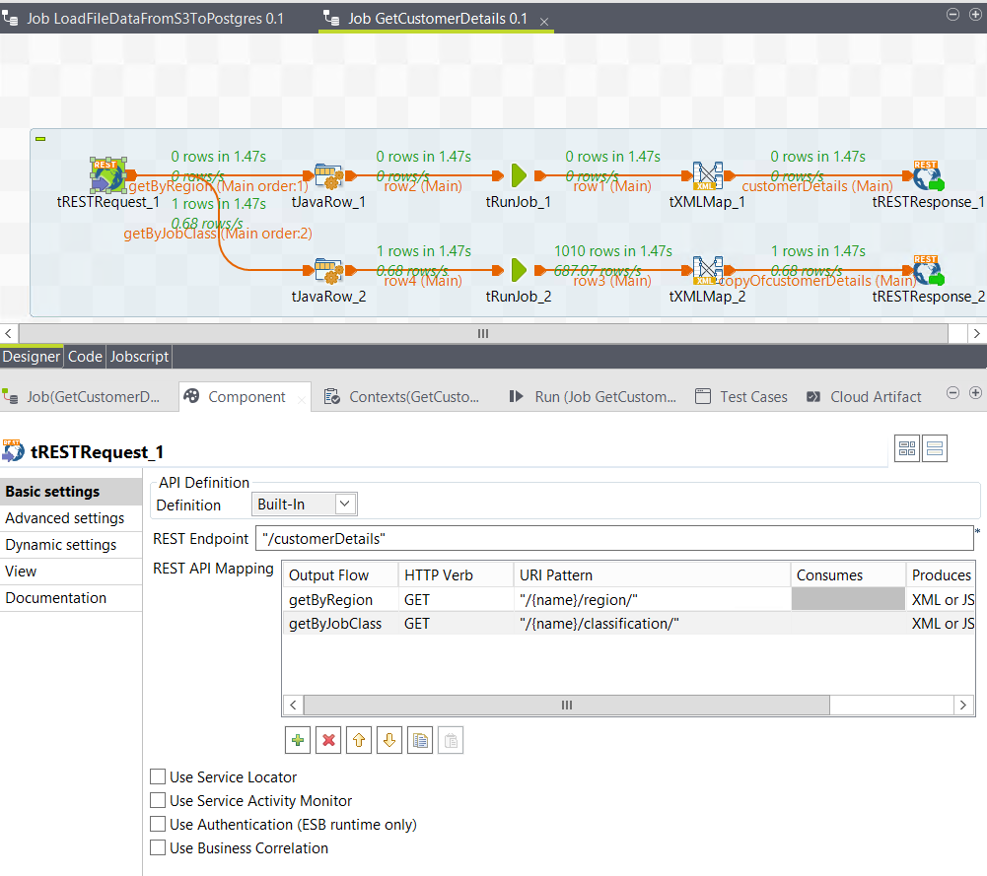

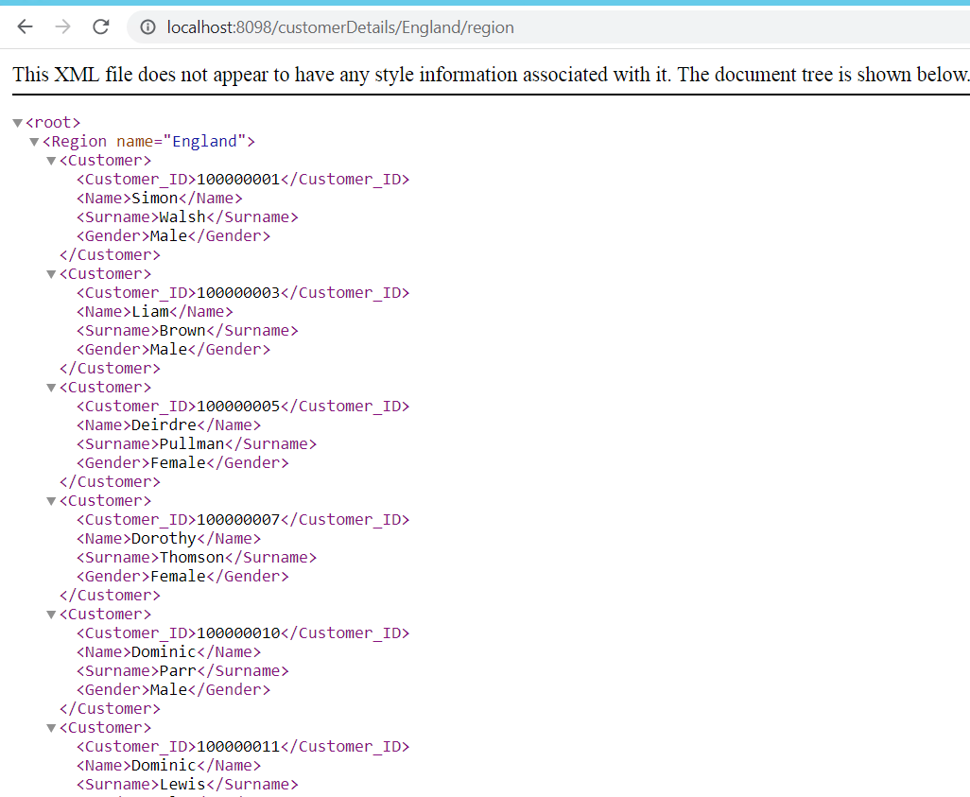

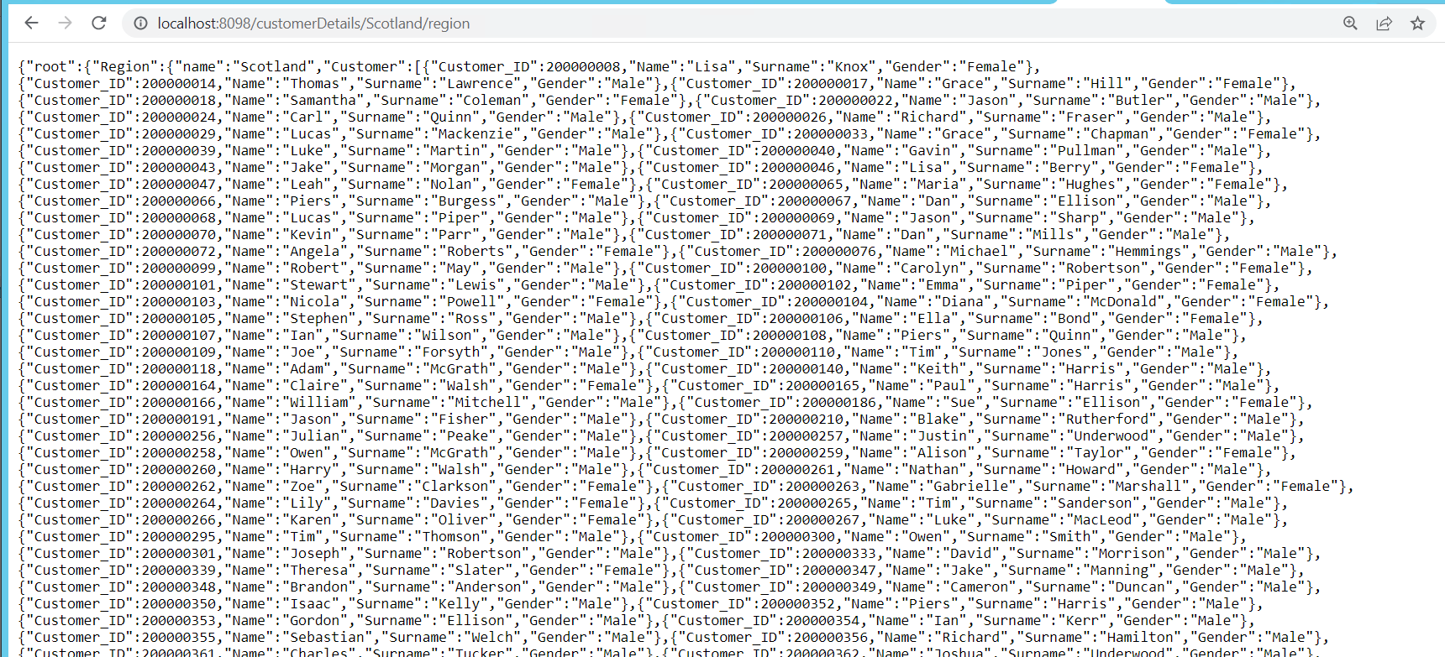

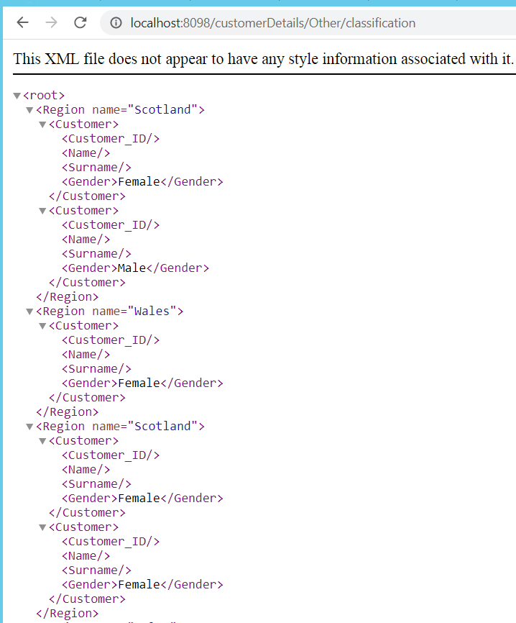

* Log File:

